MiVoice Office 250 Hardware

1. MiVoice Office 250 Hardware

1.1 MiVoice Office 250

Hardware Sales Lesson

Notes:

1.2 Why MiVoice Office 250
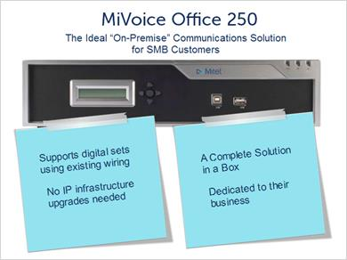
Notes:
The MiVoice Office 250 allows customers the freedom to choose between an IP, Digital or a blended communications solution.

This powerful, compact platform provides an ideal solution for the small to medium size business that prefers an “on premise” communication solution for any number of reasons. Maybe they desire or need to use existing wiring and or remain separate from their IP infrastructure. Maybe they just prefer a dedicated solution. The fact is that the majority of SMB customers still prefer premise solutions and the MiVoice Office 250 delivers everything they need in one box, at a great price.

This lesson will cover the hardware components of this solution.

1.3 Introduction to the HX Controller
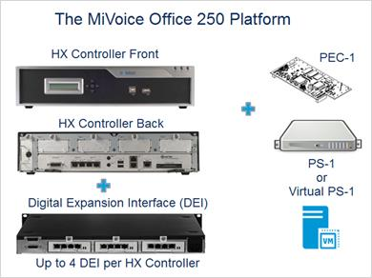
Notes:
The MiVoice Office 250 is based on the HX or Hybrid eXchange controller which can support IP, Digital, and analog media directly from the base unit, making the solution extremely cost effective.

The MiVoice Office 250 is typically sold to customers with less than 50 users, however the HX controller can accommodate up to 250 users through add-on DEI units for digital and or analog stations, as well as add-on processing power to give customers lots of room for growth.

In all up to 4 DEI units can added to the HX, a internal Processor Expansion Card or PEC-1 can be added as well as an external Processing Server or PS-1 can be added. A PEC-1 and a PS-1 can both be added for maximum processing capacity.

Even though we will cover maximum capacities, in practice it is not advisable to deploy systems at or near these maximums. Multiple systems can be networked together to avoid putting too much load on any given system, but also keep in mind that we have other MiVoice platform solutions better suited to customers with larger numbers of users.

1.4 HX Controller Tour
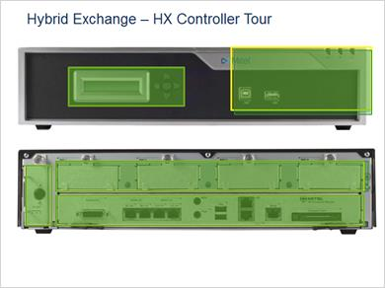
Notes:
It’s time to take a closer look at the HX controller. Please click on each of the yellow highlighted areas to explore this hardware platform.

2. The LCD display and navigation buttons provide quick access to basic administrative functions

3) Two front USB ports provide easy access for technicians to perform backup or diagnostics and LED Indicators provide visual alarm state indications.

3. These four modular expansion slots support add on option modules as shown here. This gives the HX the versatility to support both analog and digital trunks and or subscriber device ports all from this single platform.

4. The HX Power supply is external from the main chassis providing simple access for maintenance and upgrades.

5. The HX Processor Module runs the MiVoice Office 250 software, and includes a number of additional built in interfaces. Notice that 4 analog subscriber ports and 4 loop start trunks are included with the base processor. The LAN port provides the ability to support IP end points and or SIP trunks. The compact flash holds the system software and provides data storage for embedded applications such as voicemail. There are also 2 USB ports, a door relay to control entry from a phone, a port for an external music on hold input, a port to interface with overhead paging equipment, and a digital expansion interface connector to increase the digital and analog subscriber capacity if needed.

Display Panel (Slide Layer)
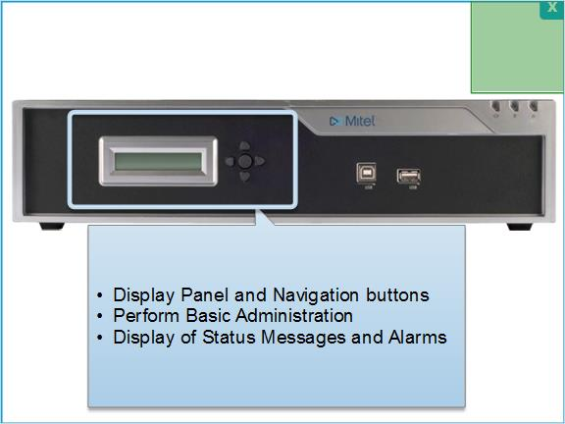

LED USB (Slide Layer)
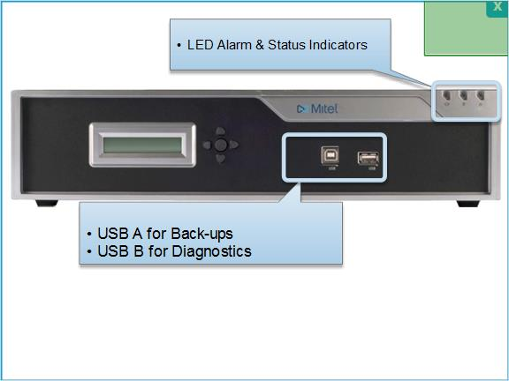

Power Supply (Slide Layer)
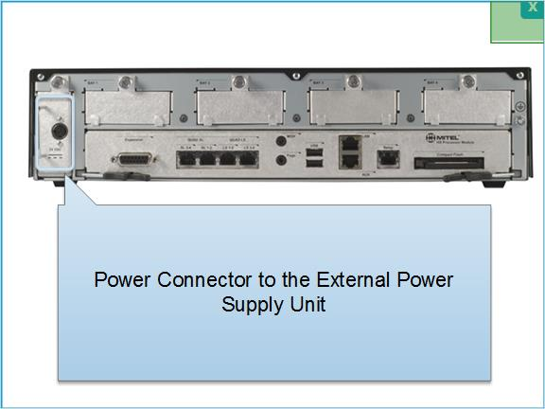

Expansion Bays (Slide Layer)
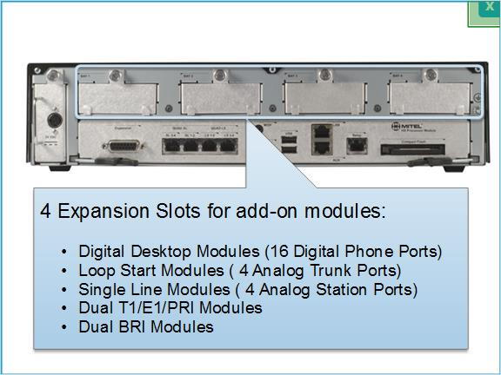

Processor Modular (Slide Layer)
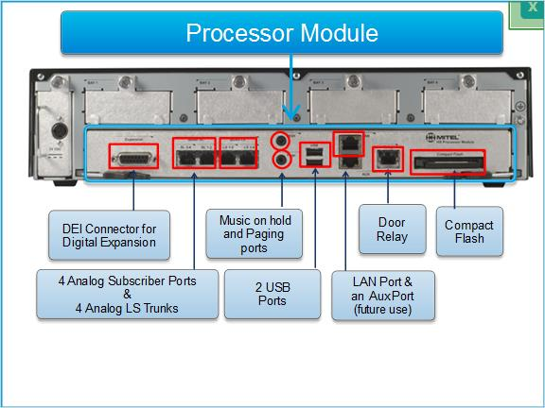

1.5 No Moving Parts
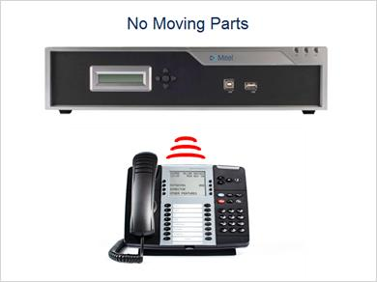
Notes:
One thing that is nice to point out to customers is that the HX controller has no moving parts, no fans, no hard drives, making it highly reliable and totally quiet.

Well at least until somebody calls

1.6 PSTN Trunking
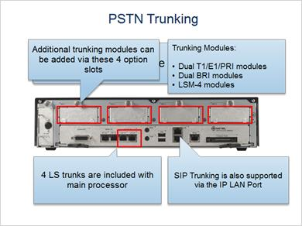
Notes:
The HX controller supports all the communications between the business and the public telephone network, so let’s first cover the PSTN trunking support. First off, all trunking interfaces are directly on the HX. No trunking is supported on DEI units.

The HX includes 4 analog LS trunks on the processor module so for very small installations no added trunking may even be needed. Additional digital or analog trunking can be added using the module slots of which there are 4 and they support any of options shown.

Dual T1/E1/PRI modules
Dual BRI modules
LSM-4 modules

Trunking can also be supported using SIP which is IP so doesn’t require an additional hardware interface. Regardless of the type of trunks used the maximum number will be limited by system engineering guidelines or the available option slots.

1.7 IP Phone Capability
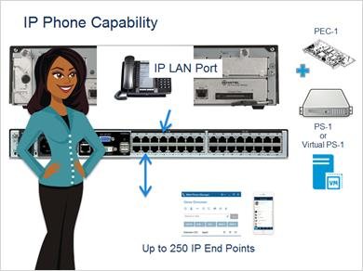
Notes:
Today, IP end points are by far the most popular and versatile and the MiVoice Office 250 is an ideal IP solution.

To support IP devices you just have to connect the MiVoice Office 250 to the IP network. After that up to 250 IP phones and or soft phones can be supported based on software licensing.

The higher the number of devices, the more the load on the processor in the HX controller. The good news is, addition processing power both internal and external can be added but depending on the configuration you may not be able to support 250 IP devices along with all the trunking, voicemail, and conferencing needs.

As always Mitel corporate systems engineering can provide configuration assistance.

1.8 IP Desktop
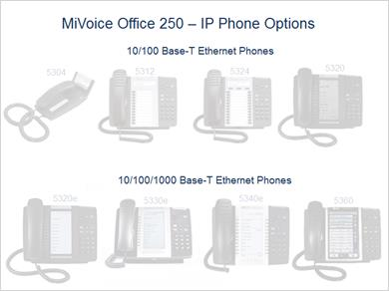
Notes:
The MiVoice Office 250 supports the Mitel 5300 series of IP desktop phones. The top row are all dual port 10/100 base-T so they all support attachment of a computer to share the same IP connection at speeds up to 100 megabit. The bottom row are all dual port 10/100/1000 so they also support a computer over the same IP connection but at speeds up to a gigabit.

In most cases if the phone will be sharing the same network connection with a computer you should use a gigabit phone.

Generally speaking the higher the model number the more the features, programmable keys, and options the phone has. You will learn all about these phones in the 5300 IP Desktop course.

5304 (Slide Layer)
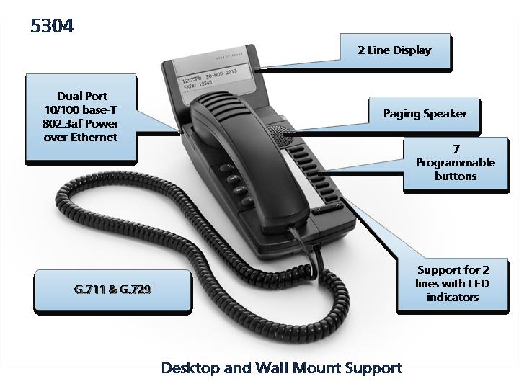

5312 (Slide Layer)
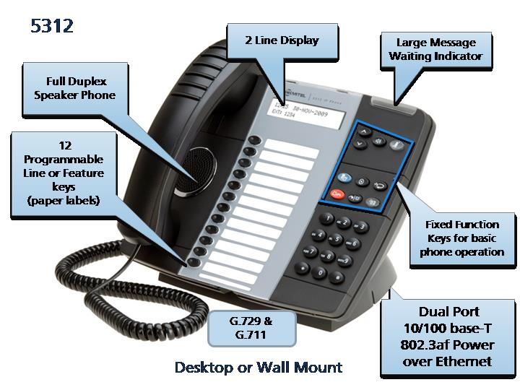

5324 (Slide Layer)
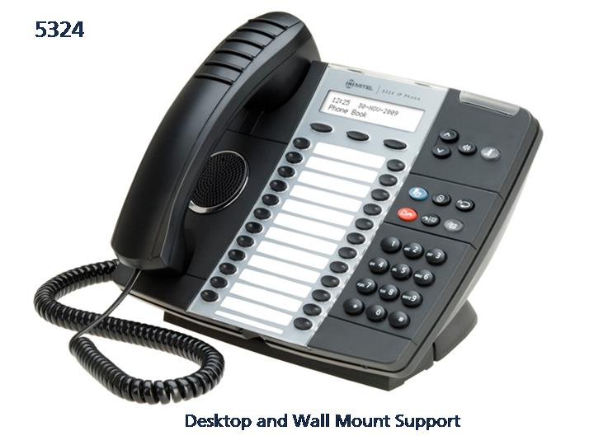

5320 (Slide Layer)
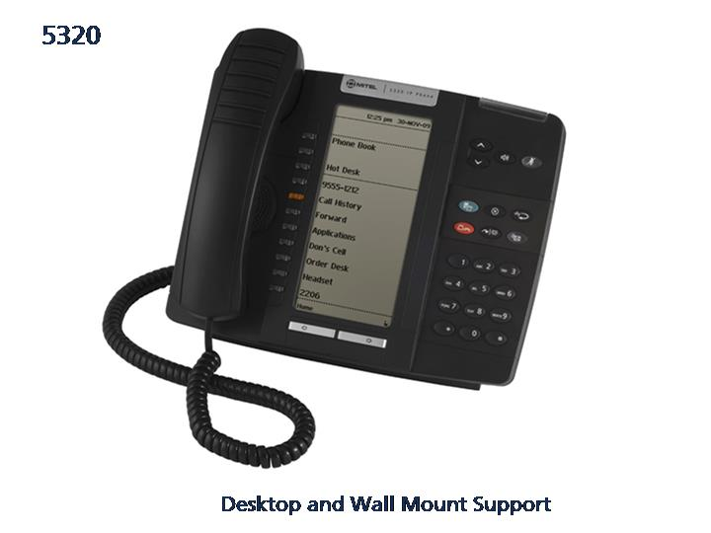

5320e (Slide Layer)
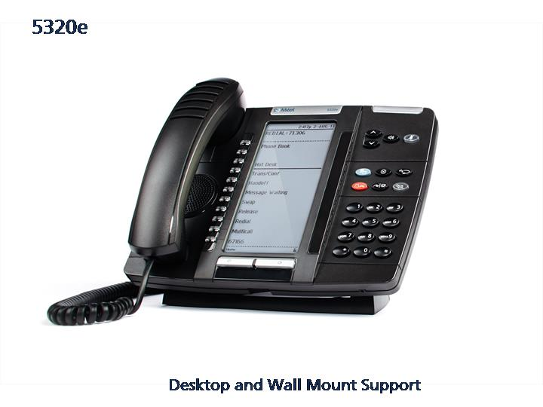

5330e (Slide Layer)
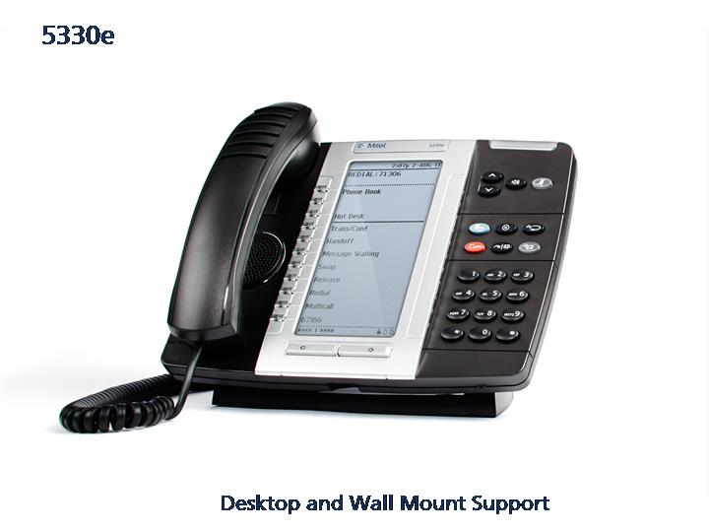

5340e (Slide Layer)
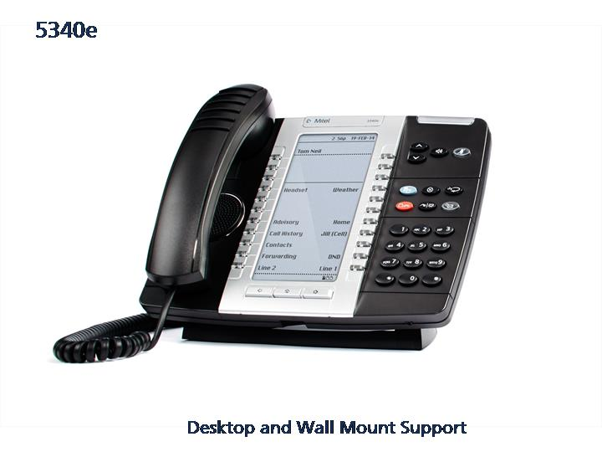

5360 (Slide Layer)
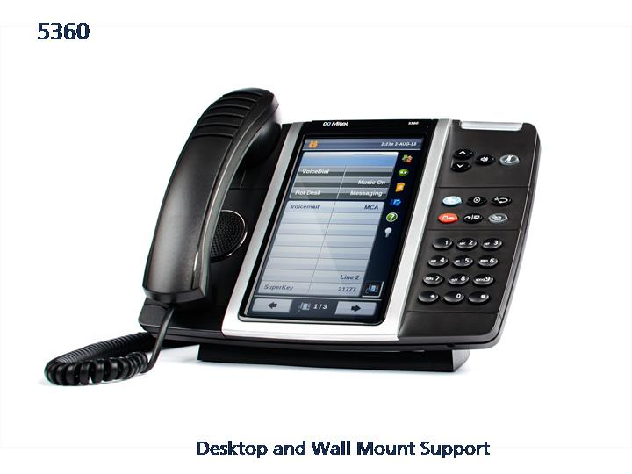

1.9 Wireless Options
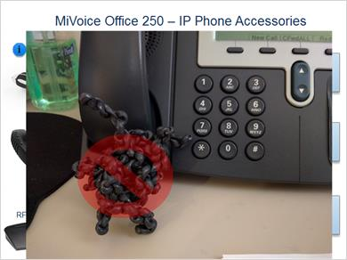
Notes:
You can show your customers how to put an end to tangled curly cords with the wireless options available for the 5330e and higher desk sets.

The wireless DECT integration option provides superb voice quality and the mobility to wander up and down the halls with your handset or headset.

The wireless Bluetooth integration option brings open compatibility so you can use a standard dual connection headset with both your desk phone and your mobile phone.

Mitel also offer both single and mult-cell IP DECT phone options as well as WiFi, and of course you can twin your mobile phone as well for that one number to ring them all convenience.

1.10 Digital End Points
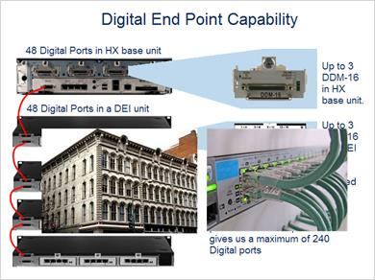
Notes:
Sometimes a customer may wish or need to use existing telephone wiring. Maybe it is an historic building and it’s too costly to add wired IP infrastructure. Maybe the customer is not comfortable with converging their voice and data over the same wire. Regardless of the ”why”, you can easily support digital phones with the HX controller. Up to 48 digital ports can be directly supported using 3 of the 4 available option slots in the HX controller.

To go beyond 48 digital ports requires DEI units.

The DEI attaches to the HX controller with a cable and provides 3 module slots for subscriber expansion. So up to 48 digital phones can be supported per DEI using 3 DEM-16 modules. Notice the DEM-16 form factor is different from the DDM-16 used to support digital end points in the base HX unit. The modules have the same capacity and perform the same function but they are not interchangeable.

Up to 4 DEI units can be daisy-chained to a single HX controller which along with the 48 ports in the HX results in a maximum of 240 digital phones.

1.11 Digital Phones
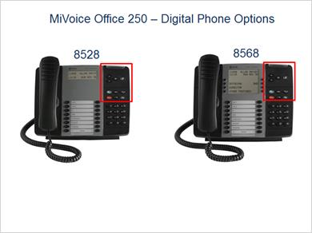
Notes:
There are 2 digital phone options for the MiVoice Office 250, the basic 8528 and the soft-key equipped 8568. Both have 16 programmable buttons. Notice the look of the phones is very similar to the 5300 IP desktop and they even have an identical set of fixed function keys so phone operation is virtually identical. So if a customer decided it was best to deploy digital in their facility due to wiring issue, but also wants IP phones in remote locations and for teleworking the MiVoice Office can easily handle this with no difference in operation for the users.

1.12 Analog Support
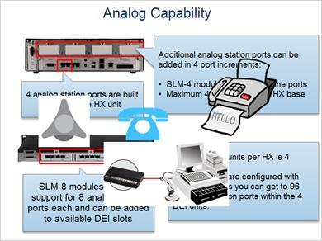
Notes:
Analog support continues to be important for many customers to support miscellaneous analog phones, analog conference units, point of sale modems and fax machines. The MiVoice Office 250 supports analog subscriber ports but it’s not designed for high capacity applications such as hotels or hospitals for which other MiVoice platform solutions are more appropriate. There are 4 analog single line station ports included with the base HX controller and additional ports can be added using SLM-4 modules in the base unit or SLM-8 modules in a DEI.

1.13 harware Benefits Recap
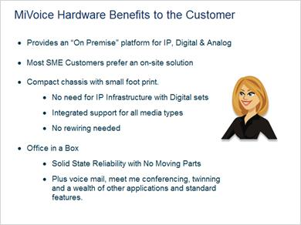
Notes:
Some key things to keep in mind about the MiVoice Office 250 is that it is a premise based solution and the majority of SME customers still prefer on-site solutions to cloud services.

The hardware is compact but versatile so you don’t need external gateways to support traditional PSTN trunks or legacy devices. You get IP, Digital, and Analog support all from a single integrated platform so the customer doesn’t have to change any infrastructure. Even customers looking for pure IP benefit from being able to plug a fax machine or a life line LS trunk right in.

Think single box, solid state reliability with no moving parts, and packed with a wealth of integrated applications that you will learn more about in the software lessons.

2. Hardware Review

2.1 Knowledge Review


2.2 Draw from Question Bank 1
Draw all questions randomly from Hardware unlimited tries

2.3 Results Slide
(Results Slide, 0 points, 1 attempt permitted)


Results for
2.2 Draw from Question Bank 1

Result slide properties
Passing Score | 80%

Success (Slide Layer)


Failure (Slide Layer)


2.4 Question? Click below to email us!

Notes:

